|  |  |
| --- | --- |
| NAME | Muhammad Arslan Raza |
| ROLL# | 2020-EE-403 |

**Lab 5: Problem Set 2**

**Objective:** The objective of this problem set is how to write different programs on compiler

**Task 1**:

A palindrome is a number or a text phrase that reads the same backward as forward. For example, each of the following five-digit integers is a palindrome: 12321, 55555, 45554 and 11611. Write a program that reads in a five-digit integer and determines whether or not it’s a palindrome.

**Code:**

x=int(input("Enter a 5 digit number"))

a=x%10

y=int(x/10)

b=y%10

z=int(y/10)

c=z%10

w=z%10

w=int(z/10)

d=w%10

e=int(w/10)

if e==a and d==b:

print("the number is palindrome")

else:

print("the number is not palindrome")

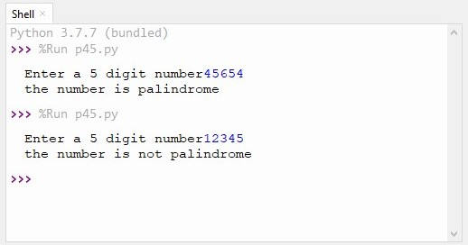**Output:**

**Task 2:**

Write a program that reads three non-zero integer values and determines and prints whether they  
could represent the sides of a triangle.

**Code:**

x=int(input("enter 1st value"))

y=int(input("enter 2nd value"))

z=int(input("enter 3rd value"))

if x+y>=z and y+z>=x and x+z>=y:

print("Values shows the sides of triangle")

else:

print("Values do not shows the sides of triangle")

**Output:**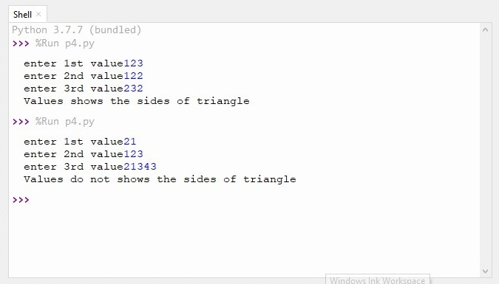

**Task 3:**

Implement a program which determines the roots of a quadratic equation (take coefficients from  
user). The program also determines if the roots of the equation are real or imaginary. Display the  
roots if they are real. Print a message on the output screen about the nature of the roots (*roots are  
real* or *roots are imaginary*).

**Code:**

import math

a=int(input("enter x square coefficient"))

b=int(input("enter x coefficient"))

c=int(input("enter constant"))

y=b**2-4*a*c

if y>=0:

print("roots are real")

x1=(-b+(math.sqrt(y)))/2*a

x2=(-b-(math.sqrt(y)))/2*a

print(x1)

print(x2)

else:

print("roots are imaginary")Output:

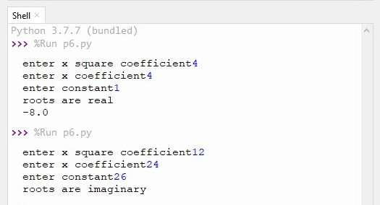

**Conclusion:**

Today I learn how to write a program that determine whether the input numbers are palindrome or not. Enter values shows the sides of triangle or not. And write a program that determine the roots of quadratic.